Getting error for msi or msp missing in catche

1. We got error while installing SQL 2016 sp3

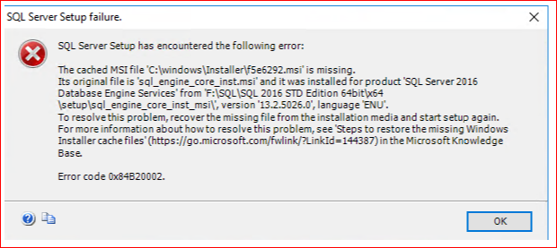

Solution:

https://www.techyv.com/questions/sql-server-setup-has-encountered-error-code-0x84b20002/

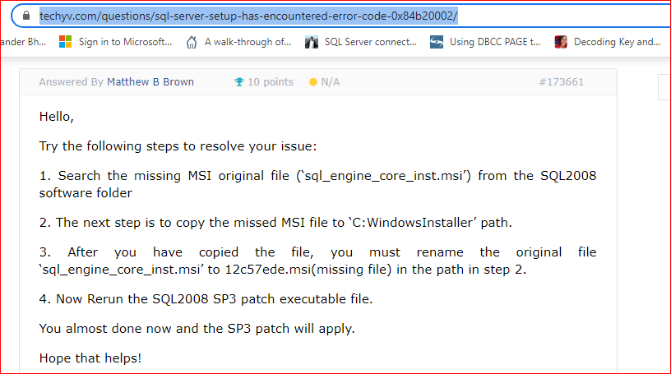

We copied above file “**sql_engine_core_inst.msi** ” from original setup

**“ \x64\Setup\sql_engine_core_inst_msi\sql_engine_core_inst.msi ”**

And paste it into “ **C:\Windows\installer** ”

Open above folder with administrator by opening **Run windows** and pressing “**shift+ctrl+enter**” buttons at same time.

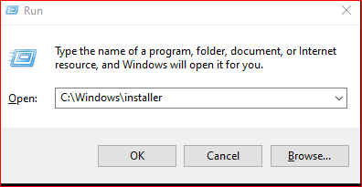

Now paste “**sql_engine_core_inst.msi**” and rename it with missing filename “**f5e6292.msi**”

1. Now we get different .msp file missing error after resolving above.

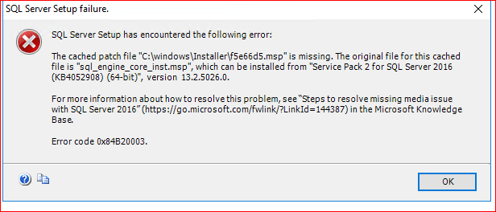

Solution:

Extract SP2 setup through the **cmd.**

Open cmd with administrator and change directory to SP2 setup file.

cd /d Setup file location

setupfile.exe /X

it will ask location to extract files

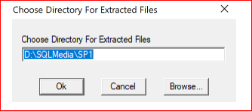

Now once extract SP2 copy “ **sql_engine_core_shared.msp** ” file from below location

“ **\x64\setup\sql_engine_core_shared_msi\sql_engine_core_shared.msp** ”

And paste it into “ **C:\Windows\installer** ”

Now paste “**sql_engine_core_inst.msi**” and rename it with missing filename “**f5e66d5.msp**”

1. After solving above error we are getting

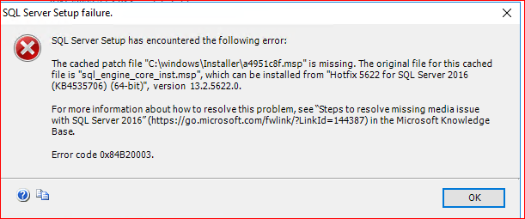

Solution:

Extract **Security Update for SP2 CU (KB4535706)** setup through the **cmd.**

Copy “ **SQL_ENGINE_CORE_INST.MSP** ” file from below location

“ **SQL 2016 KB4535706\x64\Setup\sql_engine_core_inst_msi\SQL_ENGINE_CORE_INST.MSP** ”

And paste it into “ **C:\Windows\installer** ”

Now paste “**SQL_ENGINE_CORE_INST.MSP**” and rename it with missing filename “**a4951c8f.msp**”

1. Now after resolving above

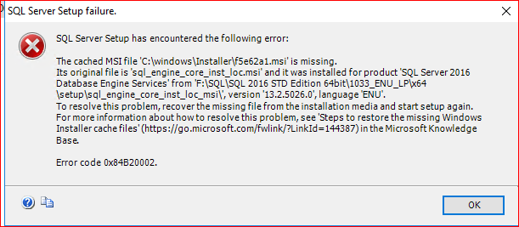

Copied file from Original Media

“ **\1033_ENU_LP\x64\Setup\sql_engine_core_inst_loc_msi\sql_engine_core_inst_loc.msi** ”

And paste it into “ **C:\Windows\installer** ”

Now paste “**sql_engine_core_inst_loc.msi**” and rename it with missing filename “**f5e62a1.msi**”

1. Now

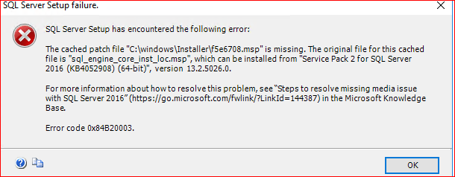

Copied file from SP2

“**SQL 2016 SP2 \KB4052908 \1033_enu_lp \x64 \setup \sql_engine_core_inst_loc_msi \sql_engine_core_inst_loc.msp**”

And paste it into “ **C:\Windows\installer** ”

Now paste “**sql_engine_core_inst_loc.msp**” and rename it with missing filename “**f5e6708.msp**”

1. Now

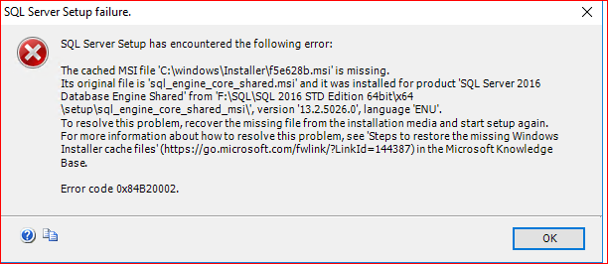

Copied file from Original Media

“ **Drive:\x64\Setup\sql_engine_core_shared_msi\sql_engine_core_shared.msi** ”

And paste it into “ **C:\Windows\installer** ”

Now paste “**sql_engine_core_shared.msi**” and rename it with missing filename “**f5e628b.msi**”

1. Now

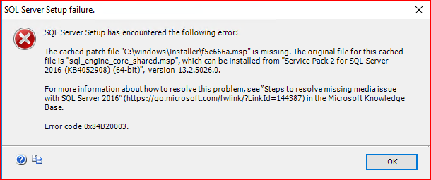

Copied file from SP2

“**Drive:\SQL Server 2016 SP2 KB4052908 \x64 \setup \sql_engine_core_shared_msi \sql_engine_core_shared.msp**”

And paste it into “ **C:\Windows\installer** ”

Now paste “**sql_engine_core_shared.msp**” and rename it with missing filename “**f5e666a.msp**”

1. Now

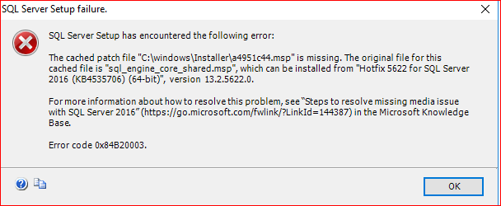

Extract **Security Update for SP2 CU (KB4535706)** setup through the **cmd.**

Copy “**SQL_ENGINE_CORE_SHARED.MSP**” file from below location

“**Drive:\SQL 2016 KB4535706 \x64 \Setup \sql_engine_core_shared_msi \SQL_ENGINE_CORE_SHARED.MSP** ”

And paste it into “ **C:\Windows\installer** ”

Now paste “**SQL_ENGINE_CORE_SHARED.MSP**” and rename it with missing filename “**a4951c44.msp**”

1. Now

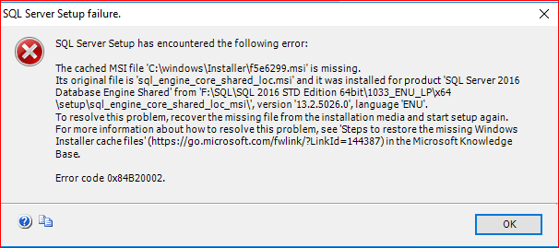

Copied file from Original Media

“**Drive:\1033_ENU_LP\x64\Setup\sql_engine_core_shared_loc_msi\sql_engine_core_shared_loc.msi**”

And paste it into “ **C:\Windows\installer** ”

Now paste “**sql_engine_core_shared_loc.msi**” and rename it with missing filename “**f5e6299.msi**”

1. Now

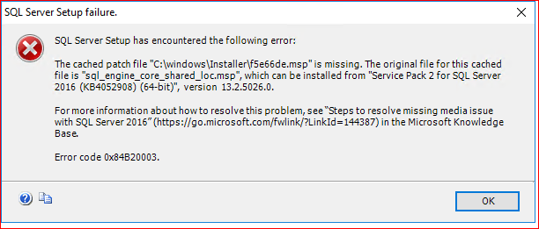

Copied file from SP2

“**Drive:\SQL Server 2016 SP2 KB4052908 \1033_enu_lp \x64 \setup \sql_engine_core_shared_loc_msi \sql_engine_core_shared_loc.msp**”

And paste it into “ **C:\Windows\installer** ”

Now paste “**sql_engine_core_shared_loc.msp**” and rename it with missing filename “**f5e66de.msp**”

1. Now

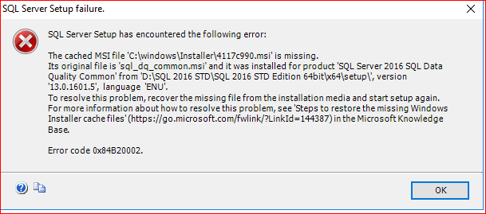

Copied file from Original Media

“**Drive:\x64\Setup\sql_dq_common.msi**”

And paste it into “ **C:\Windows\installer** ”

Now paste “**sql_dq_common.msi**” and rename it with missing filename “**4117c990.msi**”

1. Now

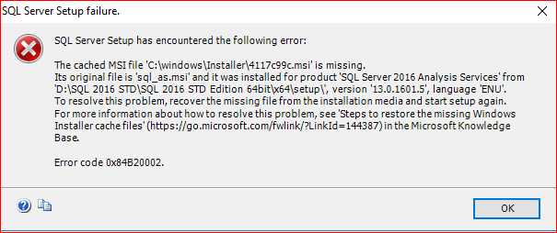

Copied file from Original Media

“**Drive:\x64\Setup\** **sql_as.msi**”

And paste it into “ **C:\Windows\installer** ”

Now paste “**sql_as.msi**” and rename it with missing filename “**4117c99c.msi**”

1. Now

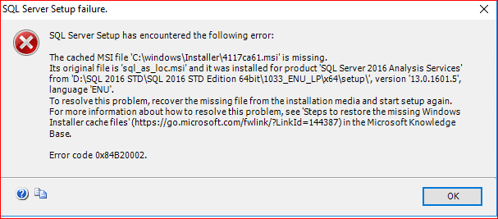

Copied file from Original Media

“**Drive:** **\1033_ENU_LP\x64\Setup\sql_as_loc.msi**”

And paste it into “ **C:\Windows\installer** ”

Now paste “**sql_as_loc.msi**” and rename it with missing filename “**4117ca61.msi**”

1. Now

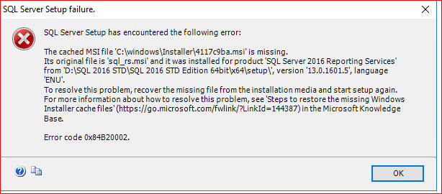

f5e6292

f5e66d5

a4951c8f

f5e62a1

f5e6708

f5e628b

f5e666a

a4951c44

f5e6299

f5e66de

4117c990

4117c99c

4117ca61

https://www.catalog.update.microsoft.com/Home.aspx